GOOD PRACTICES FOR DOCUMENTATION AND DATA INTEGRITY

Function: | Prepared by: | Reviewed by: | Approved by:
Department: | Quality Assurance | Systems and cybersecurity | Quality Assurance
Name: | Ivan Perez | David Pozo | Fernando Pozo
Signature:
Date:

Valid until: | 02/06/2028

DOCUMENT HISTORY
VERSION | CAUSES OF MODIFICATION | EFFECTIVE DATE | REPLACES (Code, Revision)
01 | Initial edition | 22/02/2024 | N/A
02 | Change in Spika's departments | 02/06/2025 | PNT-023.01

Content
1. Objective 4
2. Scope 4
3. Responsibilities and Departments affected 4
4. Definitions and Acronyms 4
5. Procedure 5
5.1. Introduction 5
5.2. Documentation characteristics 5
5.2.1. Complete 5
5.2.2. Clara 6
5.2.3. Consistent 7
5.2.4. Correct 8
5.2.5. Direct 9
5.2.6. Immediate 9
5.2.7. Permanent 9
5.2.8. Legible 9
5.2.9. Realistic 10
5.3. Permitted abbreviations 10
5.4. Data integrity 10
6. Distribution of Procedure 11
7. Annexes 11
8. Related documentation 12
9. Formation 12

- Aim
The objective of this procedure is to establish the minimum criteria and requirements that the documentation generated by Spika Tech, hereinafter Spika, must meet, in order to unify the criteria in the documentation written by staff.
- Scope
The scope of this procedure applies to all documentation generated in SPIKA.
- Responsibilities and Departments Affected
It is the responsibility of any SPIKA employee to comply with this procedure.
The affected departments are those indicated in the following table:
Department | Apply
 | Yeah | No
Address | ☒ | ☐
Environment | ☒ | ☐
Quality Assurance | ☒ | ☐
Systems and Cybersecurity | ☒ | ☐
Research and Development | ☒ | ☐
Marketing and Sales | ☒ | ☐
Management | ☒ | ☐

- Definitions and Acronyms
See section 5.3 Abbreviations.
- Procedure
  - Introduction
Good documentation is a fundamental part of the quality management system and is key to working in compliance with regulatory requirements.
The primary objective of the documentation system used must be to establish, control, monitor, and record all activities that have a direct or indirect impact on any aspect of the quality of the products being manufactured.
The Quality Management System shall include sufficient detailed instructions to facilitate a common understanding of the requirements, as well as provide sufficient records of the various processes and an evaluation of any observations, so that the continued application of requirements can be demonstrated.
Documentation can exist in different forms (including paper, electronic or photographic media) and is mainly classified into two types:
- Instructions (indications, requirements): This group includes specifications, procedures, protocols and technical agreements.
- Records/Reports.
Depending on the type of document, appropriate good documentation practices must be applied. Appropriate controls must be implemented to ensure the accuracy, integrity, availability, and legibility of documents.
  - Documentation features
    - Complete
The documentation must be complete, containing all necessary data (including units of measurement when reporting results) and all blank spaces in the document must contain information, even when it is not applicable, the acronym N/A can be used.
Quotation marks (“) are not permitted to indicate that the field being filled in contains the same data as the field above it. They must always be written, even if the information is repeated. See the following example:
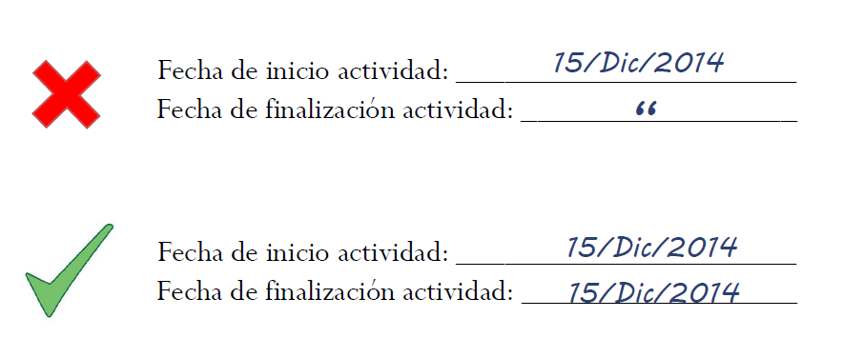
When it comes to a complete blank page or part of a page that will not be completed, a line must be drawn across the entire uncompleted portion, and the line must be signed and dated. This line can be drawn in the two ways detailed below, always ensuring that no writing can be done after the entry is completed.
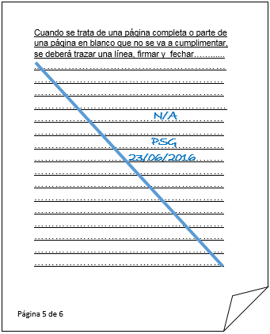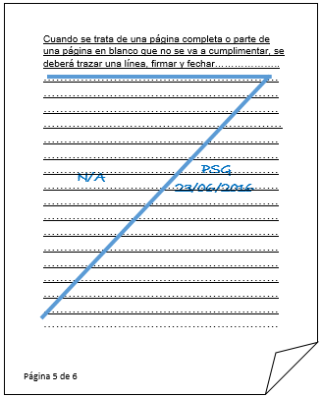
Blank pages should not be deleted from a document.
Documents must be numbered according to the model page X of Y, thus ensuring that there are no missing pages.
    - Clara
Documents must be drafted in such a way as to avoid any ambiguity: their title, nature, and purpose must be clearly stated, allowing for clear interpretation and leaving no room for doubt.
Anyone reading the document must be able to understand its meaning.
    - Consistent
Unique instructions should be established that can be repeated in the same way by different people at different times.
When writing a document, the same verb tense must be used throughout.
For the decimal expression, the grammatical sign of the comma located to the right and below the numerical sign of the unit will be used.
Eg: 21 , 2

For the expression of a thousand and its multiples, the grammatical sign of the period to the right and below the numerical sign of the thousand unit will be used.
Eg: 1 . 526

For information related to date and time entries in a document, the following guidelines should be followed:
Date Entry: To record dates, the format described below must be used:


DAY MONTH YEAR
(2 digits) (2 digits or three letters) (2 or 4 digits)
As detailed in the figure above, the date must be entered in the following order: first, the day using two digits; second, the month using two digits or the first three letters of the month; and finally, the year using two or four digits. Each digit can be separated by a diagonal line or hyphen. The four-digit format for the year is preferred, provided space permits.

Time entries: Time entries will be made using the military format (00:00-24:00 h).
E.g.: 09:05 19:21 23:19
    - Correct
The documentation must be correct, and properly prepared, reviewed, approved and distributed, according to PNT-001 Management of documents and archives.
Information should not be able to be subsequently modified unless evidence of correctness is presented.
Any modification made to written information in a document must be signed and dated; the modification must not impede the readability of the original information. If applicable, the reason for the modification must be stated. Corrections must be made by the person who provided the original information; corrections are only permitted for obvious errors. The procedure for correcting errors in a written document is detailed below:
1. Draw a single line (horizontal or diagonal, see examples) over the incorrect entry, data or information where the error was made, in such a way that the reading of the initial data is not impeded:
2. Write the correct information above or to the side (provided there is enough space; if there is not, proceed as indicated on the following page).
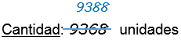
3. Write an explanation for the correction (for permitted abbreviations, see section 5.7). You must also reference the document from which the information was retrieved, if applicable.

4. Signature of the person making the correction and date on which it was made.


If it is not possible to justify the reason for the correction at the side or above it, due to not having enough space in that part of the document, it is acceptable to include the symbol * or letters next to the correction made and note it at the bottom or on the back of the page.
    - Direct
Information must be recorded directly on the document; no transcriptions should be made, as this increases the risk of errors or loss of information. Therefore, scraps of paper, Post-it notes, or sticky notes should not be used to take notes.
    - Immediate
Records must be completed at the time each activity is carried out and in a manner that allows for chronological tracking of all significant activities related to the manufacture of medicines.
Record “what was actually done at the time” rather than “what is remembered.”
You should never set a date before or after the current one.
    - Permanent
When recording data/information in a written document, this information must not be erasable or deleted later. Therefore, the use of pencils, markers, liquid-ink pens, and Tipp-Ex correction fluids is prohibited.
Always use a blue indelible ink pen .
As a general rule, the use of red ink pens is not permitted.
    - Readable
Information should be presented clearly and not misleading. The size used should be sufficient to allow for legibility. There should be adequate space between notes.
Special attention must be paid to the legibility of numbers and characters to avoid confusion. For example, some digits and letters that can often be confused with each other are:
- 0 and 6
- 3 and 8
- 5 and S
- 1 and 7
- B and 8
- U and V
- 0 and O
    - Realistic
The documented information must be true and must be documented by the person who performed the activity. Information must never be falsified.
The signatures confirm that the information signed is true. This signature is personal and non-transferable and must be recorded on the corresponding sheet of the signature recognition booklet, prepared according to procedure PNT-017-Signature Registration . No signature other than the one recorded should be used.
In those activities that require the signature of the person performing the activity and the signature of the person reviewing or verifying, these signatures cannot belong to the same person.
  - Allowed abbreviations
Below is a list of the abbreviations to use when making any notes on a document:
EA: Annotation error
EC: Calculation error
ED: Data error
EE: Typing error
EG: Grammatical error
ET: Transcription error
N/A or NA: Not applicable
  - Data integrity
Data integrity requirements apply to both paper (manual) and electronic records and are essential to ensuring that data is complete, consistent, and accurate.
The data must comply with the ALCOA rule:
A Attributable to the person who records the data.
L Legible and permanent.
C Contemporary: recorded at the time.
The Original (or true copy of the original).
A (from the English accurate) Exact, precise.
There are several ways to ensure data integrity, some of which may be:
- Follow good documentation practices.
- Implement control systems to detect or reduce errors (e.g., second-person verification, computerized data capture systems, etc.).
- Separate roles for access to computerized systems, as well as using and reviewing system audit trails.
- Prevent unauthorized access and use strong passwords to access systems, with at least 8 alphanumeric characters and symbols.
It must be ensured that each employee has only the access appropriate for their position, that they are trained in the applicable system, and that all actions are attributable to the individual(s) performing them. Therefore, any employee who detects that data integrity is being or may be violated must notify their immediate supervisor.
- Distribution of the Procedure
Staff members in the departments listed in Section 3 (Responsibilities and Affected Departments) must be provided with a copy of this procedure. In addition, controlled copy No. 1 will be submitted to the Archives for paper archiving.
Controlled copies to be issued:
Controlled Copy No. | Departments
1 | Archive

- Annexes
NO. / REV. | QUALIFICATION
N/A | N/A
- Related documentation
Code | QUALIFICATION
PNT-001 | Document and archive management
PNT-017 | Signature register
- Training
This version requires that the affected departments indicated in section 3 receive the training indicated below:
Mark with an X | Type of training
☒ | Theoretical (reading and understanding of the procedure)
☐ | Theoretical – Practical (If you select this option, contact the Responsible Technician)

